**Lab Exercise 8**

**Creating a Freestyle Build Job**



Steps to be followed:

1. Create a GitHub repository
2. Add a Java program to the repository
3. Create a freestyle build job in Jenkins
4. Build the Java program with Jenkins

**Step 1: Create a GitHub repository**

* 1. Open the browser in your lab.



* 1. Go to <https://github.com/> link.

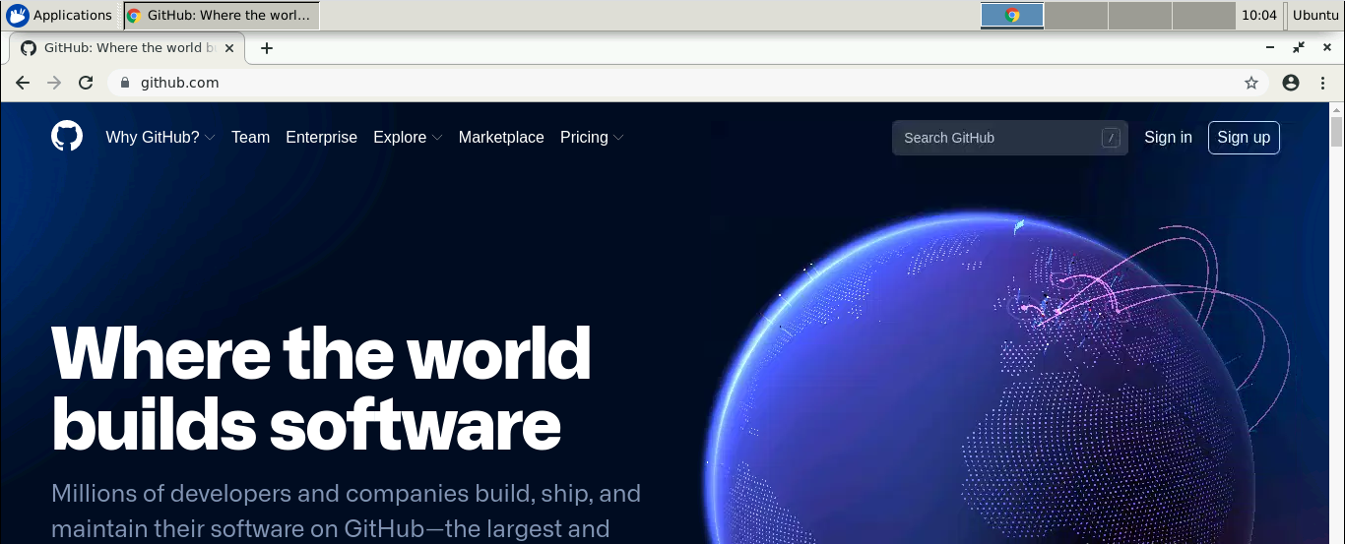

* 1. Click on **Sign in** and enter the credentials of your GitHub account to login.

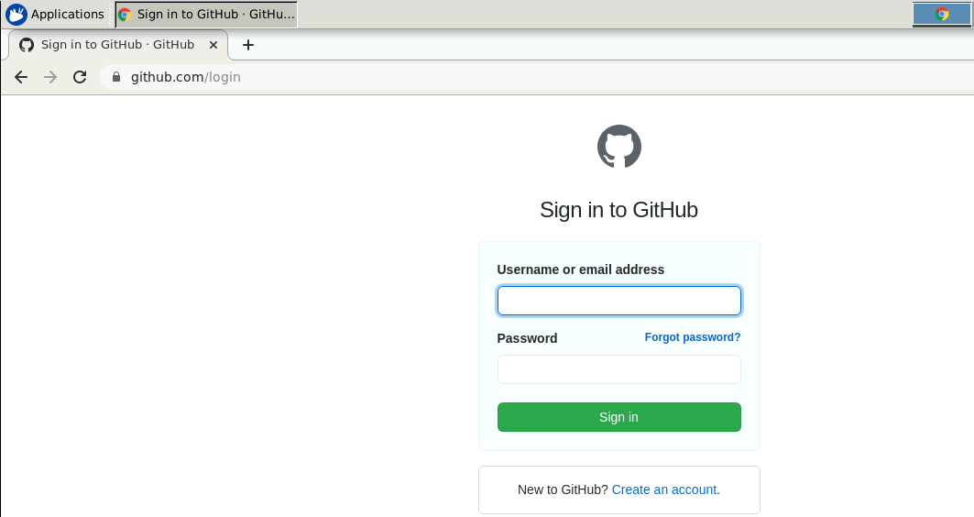

* 1. Click on **+** symbol and select **New repository**.

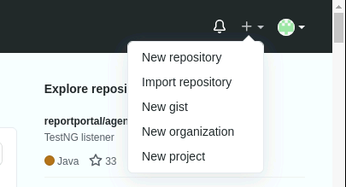

* 1. Provide the repository name.

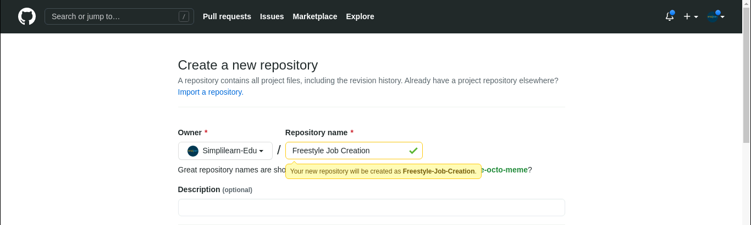

* 1. Select the check box of **ADD a README file** and click on **Create repository**.

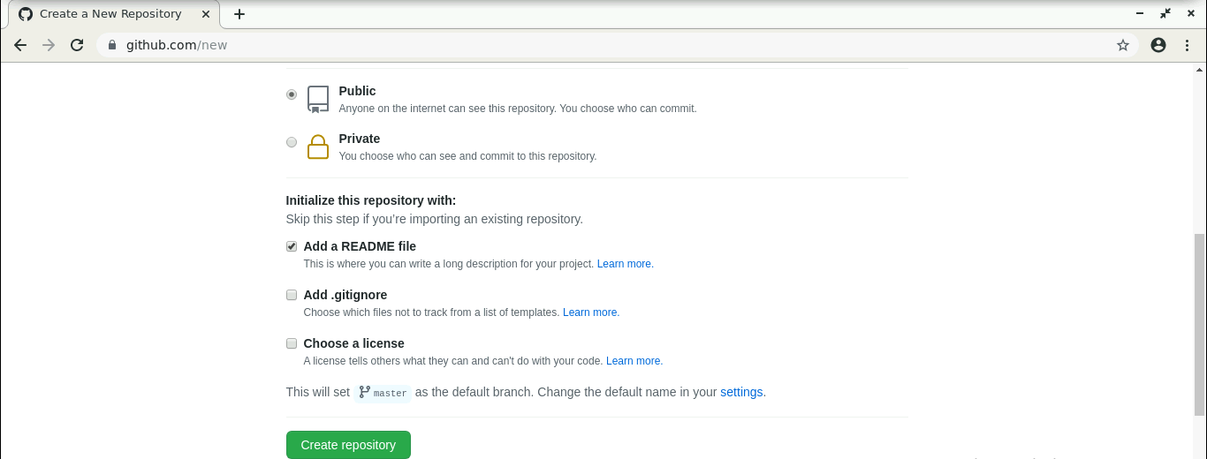

* 1. Click on **Code**.
  2. Click on **HTTPS**.
  3. Copy the repository URL.

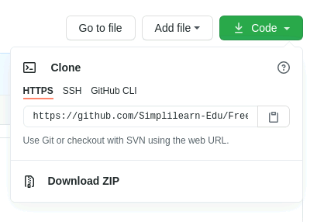

**Step 2: Add a Java program to the repository**

* 1. Open the terminal.
  2. Run ***mkdir hello-world*** to create a directory.
  3. Navigate to the hello-world directory. Run ***cd hello-world*** command.
  4. Run ***vi******HelloWorld.java*** to open the java file in a text editor.

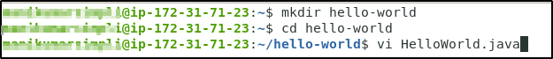

2.5 Paste the code below into the file:

***public class HelloWorld {***

***public static void main(String[] args) {***

***System.out.println("Hello, World");***

***}***

***}***

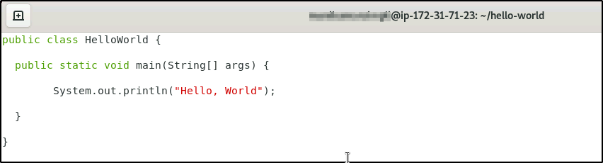

* 1. Save the file and exit the text editor.
  2. Run the ***git init*** command.
  3. Run ***git add .*** command.
  4. Run ***git commit -m “Add new files”*** command.
  5. Run ***git remote add origin <Repository_URL>*** command.
  6. Run ***git push -u origin master*** command.

**Step 3: Create a freestyle build job in Jenkins**

* 1. In the browser, type **localhost:8080** and it will open Jenkins.

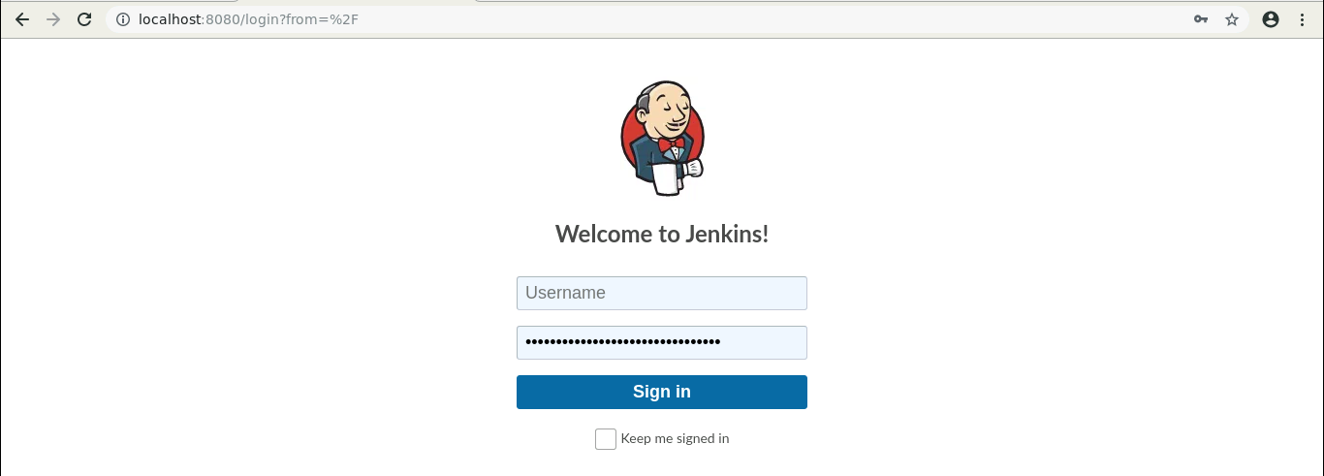

* 1. Provide the credentials and click on **Sign in**.
  2. Click on **New Item** in the Jenkins dashboard.

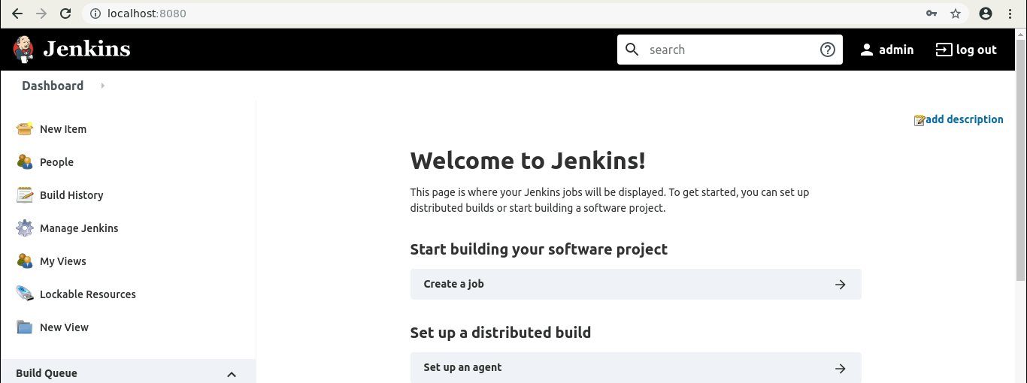

* 1. Enter a name for your project.
  2. Select **Freestyle project** as the build job type.

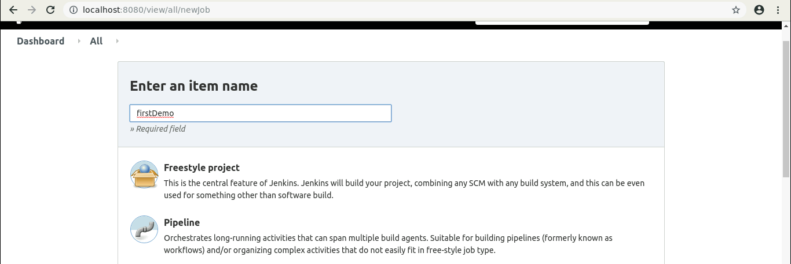

* 1. Click on **OK**.
  2. Scroll down to the **Source Code Management section** and select **Git**.
  3. Enter the repository URL.

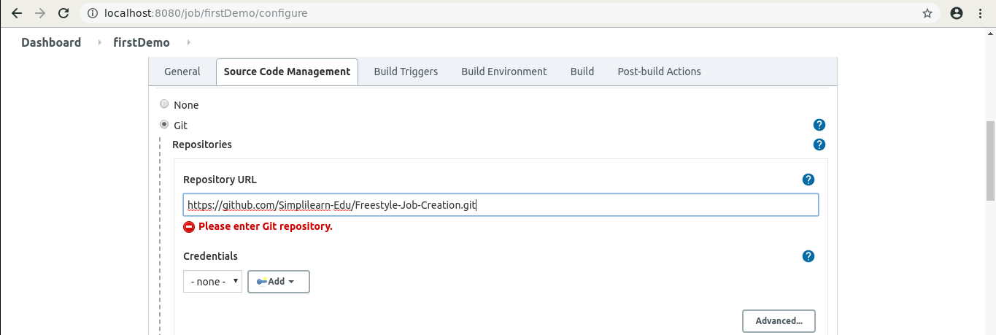

* 1. Click on **Save**.

**Step 4: Build the Java program with Jenkins**

* 1. Click on the project name in the Jenkins dashboard.
  2. Click **Build Now** in the project window. Jenkins will now build your project.

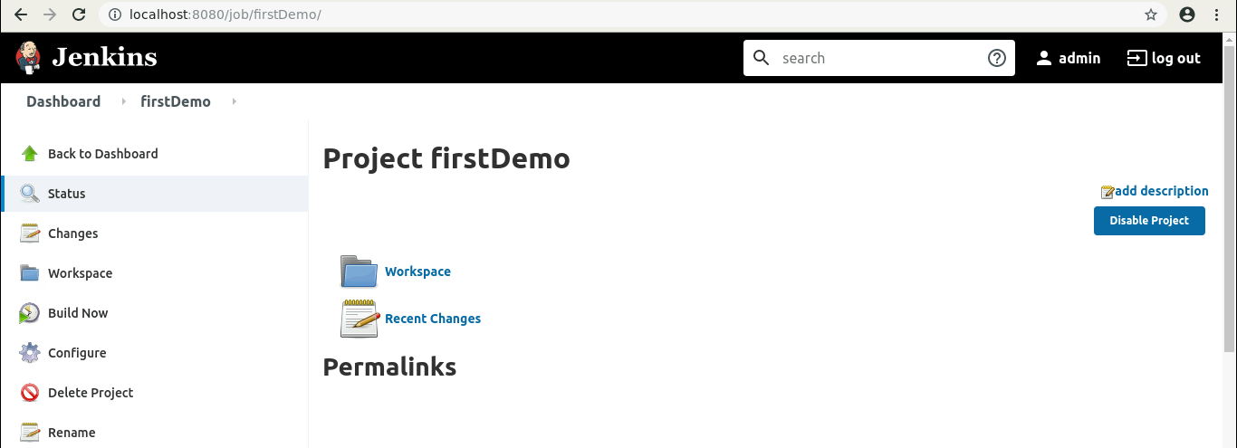

* 1. Click on **Build History** to view the build results.

4.4 Click on the **Console Output** to view the build logs.

